**Name: sruthy chandran**

**Roll No:43**

**Batch:mca**

**Date:28/03/22**

**ADVANCED DBMS LAB**

**Experiment No.: 1**

**Aim**

To study various DDL commands – CREATE, INSERT

**QUESTION**

Create the following Tables and Insert values.

**Table 1: DEPOSIT**

ACTNO VARCHAR (5) PRIMARY KEY, FIRST LETTER MUST START WITH ‘D’

CNAME VARCHAR (20) FOREIGN KEY REFERENCES CUSTOMER

BNAME VARCHAR (20) FOREGIGN KEY REFERENCES BRANCH

AMOUNT NUMBER (8,2) NOT NULL, CANNOT BE 0

ADATE DATE

**Table 2: BRANCH**

BNAME VARCHAR2(20) PRIMARY KEY

CITY VARCHAR2(30) NOT NULL , any one of NAGPUR, DELHI, BANGALORE, BOMBAY

**Table 3: CUSTOMER**

CNAME VARCHAR (15) PRIMARY KEY

CITY VARCHAR (20) NOT NULL

**Table 4: BORROW**

LOANNO VARCHAR (28) PRIMARY KEY / FIRST LETTER MUST START WITH ‘L’

CNAME VARCHAR (15) FOREIGN KEY REFERENCES CUSTOMER

BNAME VARCHAR2(20) FOREIGN KEY REFERENCES BRANCH

AMOUNT NUMBER(8,2) NOT NULL, CANNOT BE 0

**PROCEDURE**

1. **Customer table (Create and Insert)**



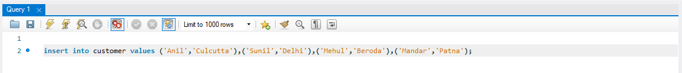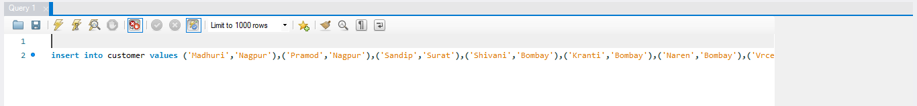

1. **Branch (Create and Insert)**

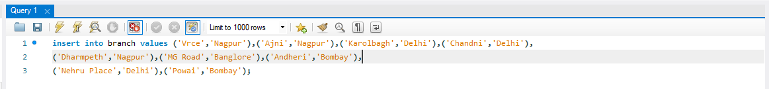

1. **Borrow (Create and Insert)**

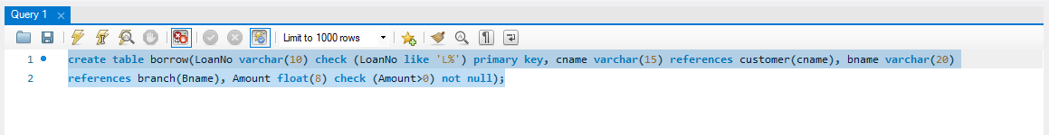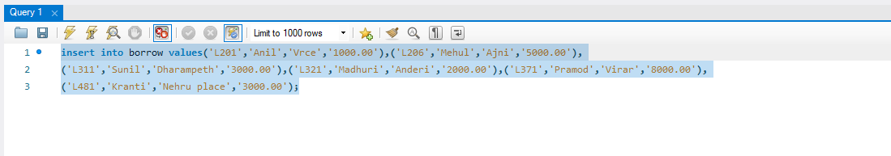

1. **Deposit (Create and Insert)**

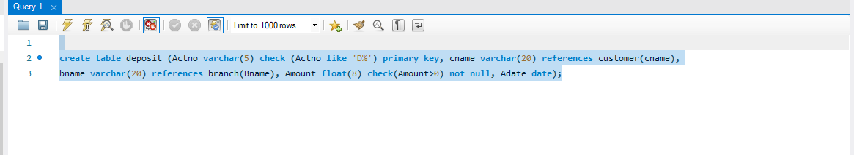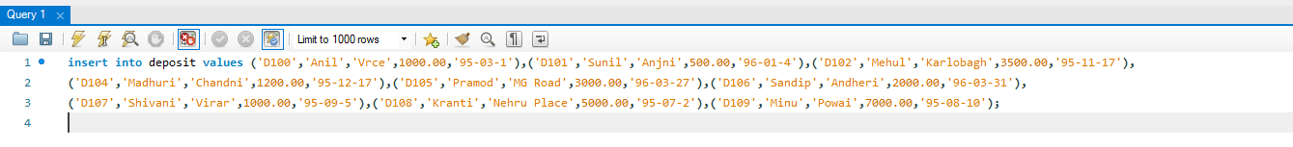

**Output Screenshot**

1. **Customer Table**

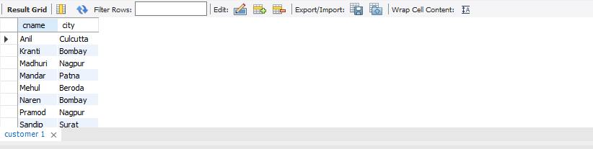

1. **Branch Table**

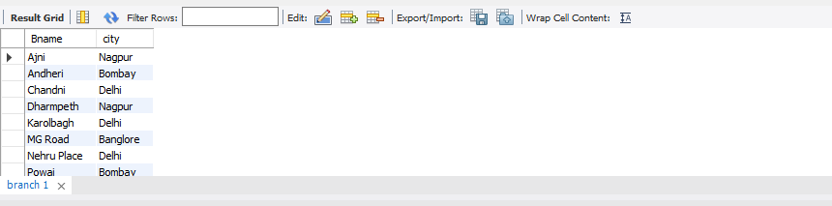

1. **BORROW TABLE**

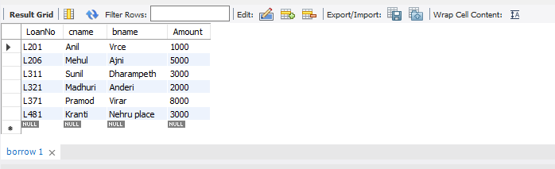

1. **DEPOSIT TABLE**

